

Addis Ababa Science and Technology University

College of Engineering

Department of Software Engineering

Simulation and Modeling  
Section B

|  |  |
| --- | --- |
| Name | ID |
| Heyeman Abdisa | ETS0632/13 |
| Hikma Anwar | ETS0633/13 |
| Hunde Desalegn | ETS0643/13 |
| Ifa Tolla | ETS0647/13 |
| Iman Ahmed | ETS0648/13 |
| Senait Mengesha | ETS1602/13 |

Submission date: January 23, 2025  
 Submitted to:

**Table of Contents**

1. Introduction 3
   1. Overview of Sorting Algorithms 3
   2. Relevance to Software Engineering 3
   3. Objectives and Scope 4

1.5 Importance of Simulation and Modeling in Algorithm Performance Evaluation 5

1. Problem Definition 6
   1. Problem Statement 6
   2. Real-Life Scenario or Application 6
   3. Assumptions and Constraints 7
2. Conceptual Model 9
   1. Model Overview 9
   2. Variables, Parameters, and Relationships 9
   3. Diagrams 11
3. Data Collection and Input Analysis 14
   1. Data Sources 14
      1. Synthetic Data Generation 14
   2. Preprocessing Steps 15
   3. Input Distributions or Patterns 16
   4. Data Generation Implementation 17
4. Simulation Design 19
   1. Choice of Simulation Technique 19
   2. Implementation in Python 20
5. Model Verification and Validation 22
   1. Verification (Are We Building It Right?) 22
   2. Validation (Are We Building the Right Thing?) 23
   3. Validation Through Controlled Experiments 24
   4. Error Handling and Robustness 24
6. Experimentation 25
   1. Experimental Design 25
   2. Factors to Vary 26
   3. Output Recording 27
7. Results and Analysis 29
   1. Simulation Results Overview 29
   2. Detailed Performance Metrics 29
   3. Impact of Data Distribution on Algorithm Performance 31
   4. Comparative Analysis of Sorting Algorithms 31
   5. Visual Insights and Interpretation 32
   6. Summary of Findings 33
8. Conclusion 34

# Introduction

## Overview of Sorting Algorithms

Sorting algorithms are fundamental components in computer science and software engineering, responsible for arranging data in a specified order, typically ascending or descending. These algorithms play a pivotal role in optimizing the efficiency of other algorithms, such as search algorithms, data processing tasks, and database management systems. Sorting is essential in various applications, including:

* Data Organization: Structuring data for easier access and retrieval.
* Search Optimization: Enhancing the performance of search operations by organizing data systematically.
* Data Analysis: Facilitating statistical analysis and reporting by ensuring data is ordered correctly.
* E-commerce Platforms: Enabling efficient product sorting based on user preferences and queries.

Sorting algorithms can be broadly categorized into comparison-based and non-comparison-based methods:

* Comparison-Based Algorithms: These algorithms sort data by comparing elements. Common examples include Bubble Sort, Insertion Sort, Merge Sort, QuickSort, and HeapSort. Their

performance is generally bounded by O(nlogn) in the average and O( 2) in the worst cases.

𝑛

* Non-Comparison-Based Algorithms: These algorithms do not sort by directly comparing

elements. Instead, they utilize properties of the input data, such as counting occurrences or distributing elements into buckets. Counting Sort is a prime example, offering linear time complexity under specific conditions.

Understanding the performance characteristics of these algorithms under various conditions is crucial for selecting the most appropriate one for a given application.

## Relevance to Software Engineering

In the realm of software engineering, the choice of sorting algorithm can significantly impact the overall performance and efficiency of software systems. Efficient sorting enhances the responsiveness and scalability of applications, particularly those handling large volumes of data. For instance:

* Database Systems: Efficient sorting algorithms optimize query processing and data retrieval operations.
* E-commerce Platforms: Quick and efficient sorting improves user experience by enabling real-time product sorting based on price, popularity, or user ratings.
* Data Processing Pipelines: Sorting algorithms contribute to the performance of data transformation and aggregation tasks, ensuring timely data analysis and reporting.

Moreover, with the advent of big data and real-time processing requirements, understanding the

performance dynamics of sorting algorithms becomes even more critical. Simulation and modeling provide valuable insights into how these algorithms behave under different scenarios, such as varying data sizes, distributions, and system constraints. This knowledge aids in making informed decisions that balance performance, resource utilization, and application requirements.

## Objectives and Scope

The primary aim of this mini-project is to evaluate and compare the performance of various sorting algorithms, including both comparison-based and non-comparison-based methods, under different input conditions using simulation and modeling techniques in Python. This comprehensive analysis seeks to provide actionable insights into the suitability of each algorithm for specific real-world scenarios.

Specific Objectives:

1. Algorithm Implementation: Develop Python implementations for a selected set of sorting algorithms, including Bubble Sort, Insertion Sort, Merge Sort, QuickSort, and Counting Sort.
2. Simulation Framework: Design and implement a simulation framework to systematically evaluate the performance of these algorithms across different input sizes and data distributions.
3. Performance Metrics: Measure and analyze key performance metrics such as runtime and memory usage to assess the efficiency and scalability of each algorithm.
4. Comparative Analysis: Conduct a comparative analysis to identify the strengths and weaknesses of each algorithm under various conditions, providing recommendations for algorithm selection based on empirical data.
5. Visualization and Reporting: Present the findings through comprehensive visualizations and detailed documentation, facilitating a clear understanding of the performance dynamics of each algorithm.

Scope of the Project:

* + Algorithms Evaluated:
    - Comparison-Based: Bubble Sort, Insertion Sort, Merge Sort, QuickSort.
    - Non-Comparison-Based: Counting Sort.
  + Input Conditions:
    - Input Sizes: Ranging from small (1,000 elements) to large datasets (1,000,000 elements) to observe scalability.
    - Data Distributions: Including random, nearly sorted, and reverse sorted to evaluate algorithm performance under different data characteristics.
    - Value Range for Counting Sort: Ensuring that data fits Counting Sort's requirements by maintaining a manageable range of integer values.
  + Performance Metrics:
    - Runtime: Execution time measured in seconds using high-resolution timers.
    - Memory Usage: Peak memory consumption tracked using Python's tracemalloc module.
  + Implementation Environment:
    - Programming Language: Python 3.7 or higher.
    - Libraries: Utilizing numpy, pandas, matplotlib, and seaborn for data generation, handling,

and visualization.

* + Constraints:
    - Single-Threaded Execution: Focusing on single-threaded implementations to maintain consistency across algorithm evaluations.
    - Data Type: Limiting to integer arrays to accommodate Counting Sort and simplify data handling.

By adhering to this scope, the project aims to deliver a comprehensive and insightful analysis of sorting algorithm performance, leveraging simulation and modeling to bridge theoretical concepts with practical applications in software engineering.

## Importance of Simulation and Modeling in Algorithm Performance Evaluation

Simulation and modeling are powerful techniques in computer science, enabling the replication and analysis of complex systems under various conditions without the need for extensive physical experimentation. In the context of algorithm performance evaluation, these techniques offer several advantages:

* + - Controlled Environment: Simulations provide a controlled setting where variables can be systematically manipulated to observe their effects on algorithm performance.
    - Scalability Testing: Modeling allows for the testing of algorithms against large datasets and varying input sizes, facilitating the assessment of scalability and efficiency.
    - Cost-Effectiveness: Simulating algorithm performance is more cost-effective and time-efficient compared to deploying algorithms in real-world systems, especially during the preliminary evaluation stages.
    - Insightful Analysis: Through detailed data collection and visualization, simulations offer deep insights into algorithm behavior, uncovering patterns and performance trends that inform decision-making.
    - Flexibility: Simulation frameworks can be easily adapted to test different algorithms, input distributions, and performance metrics, providing a versatile tool for comprehensive evaluations.

Incorporating simulation and modeling into algorithm performance evaluation bridges the gap between theoretical analysis and practical application, ensuring that algorithm selection is grounded in empirical evidence tailored to specific software engineering needs.

# Problem Definition

## Problem Statement

Efficient data sorting is a cornerstone of numerous software applications, ranging from simple data organization tasks to complex system operations like database management and real-time data processing. The choice of sorting algorithm can significantly influence the performance, scalability, and resource utilization of these applications. Despite extensive theoretical analysis of various sorting algorithms, practical performance evaluation under diverse conditions remains essential for informed

decision-making in software engineering.

Specific Problem:

To evaluate and compare the performance of multiple sorting algorithms, including both comparison-based (Bubble Sort, Insertion Sort, Merge Sort, QuickSort) and non-comparison-based

(Counting Sort) methods, under varying input sizes and data distributions using simulation and modeling techniques in Python. This comparative analysis aims to provide empirical insights into the efficiency and scalability of each algorithm, thereby guiding algorithm selection for real-world software engineering applications.

Key Questions Addressed:

1. Runtime Efficiency: How do different sorting algorithms perform in terms of execution time as the input size scales from small to large datasets?
2. Memory Consumption: What are the memory usage patterns of each sorting algorithm under various data conditions?
3. Impact of Data Distribution: How does the initial ordering of data (random, nearly sorted, reverse sorted) affect the performance of each sorting algorithm?
4. Applicability of Counting Sort: Under what conditions does Counting Sort outperform comparison-based algorithms, and what are its limitations?

By systematically addressing these questions, the project seeks to bridge the gap between theoretical algorithm analysis and practical performance evaluation, providing actionable insights for software engineers and developers.

## Real-Life Scenario or Application

Consider an e-commerce platform that manages an extensive inventory of products. Users frequently perform search queries that require sorting products based on various criteria such as price, popularity, rating, or relevance. The efficiency of the sorting algorithm directly impacts the platform's responsiveness and user experience. For instance:

* Real-Time Product Sorting: When a user filters products by price range or sorts them by popularity, the system must quickly sort potentially thousands of items to present the results in real-time.
* Scalability Concerns: As the number of products grows, the sorting algorithm must maintain performance to ensure consistent user experience without delays.
* Resource Optimization: Efficient sorting algorithms can reduce server load and memory usage, leading to cost savings and improved system reliability.

Application Relevance:

* Performance Optimization: Selecting the most efficient sorting algorithm based on data characteristics can enhance the platform's performance, leading to faster query responses and higher user satisfaction.
* Scalability Planning: Understanding how different algorithms scale with data size aids in planning for future growth and ensures that the system remains robust under increased load.
* Resource Management: Efficient algorithms contribute to optimal resource utilization, minimizing memory consumption and processing time, which is crucial for maintaining operational costs.

Beyond e-commerce, the findings of this project are applicable to various domains such as database systems, data analytics platforms, and any software application that relies heavily on data sorting and organization.

## Assumptions and Constraints

Assumptions:

1. Data Characteristics:
   * All data to be sorted consists of non-negative integers. This assumption ensures the applicability of Counting Sort and simplifies data handling.
   * The datasets fit entirely into the system's main memory, avoiding the need for external storage or disk-based sorting mechanisms.
2. Execution Environment:
   * The simulations are conducted in a single-threaded Python environment, ensuring consistency across algorithm evaluations without the complexities introduced by parallelism.
   * The system running the simulations has sufficient memory and processing power to handle large datasets (up to 20,000 elements) without significant hardware-induced performance variability.
3. Algorithm Implementations:
   * Sorting algorithms are implemented from scratch in Python to ensure uniformity in performance measurement and to avoid biases introduced by optimized library functions.
   * The implementations are correct and adhere strictly to their respective algorithmic definitions, ensuring that performance metrics accurately reflect algorithmic efficiency.
4. Simulation Consistency:
   * Random seeds are set for data generation to ensure reproducibility of results across multiple trials.
   * Environment variables such as Python version, operating system, and hardware

specifications are documented to account for any potential influence on performance metrics.

Constraints:

1. Performance Measurement Limitations:
   * Python's interpreted nature may introduce overheads that obscure the intrinsic performance characteristics of the sorting algorithms.
   * Garbage collection and other background processes in Python can affect memory usage measurements, potentially introducing variability in the results.
2. Counting Sort Specific Constraints:
   * Range of Input Values (k): Counting Sort requires that the maximum value in the dataset

(k) is not excessively large relative to the input size (n), as this directly impacts memory consumption.

* + Applicability to Data Types: Counting Sort is limited to sorting integers. Extending its applicability to other data types would require modifications or alternative

non-comparison-based algorithms.

1. Scope of Analysis:
   * The project focuses solely on a subset of sorting algorithms, excluding others like Radix Sort, TimSort, or hybrid algorithms, to maintain manageability within the project’s scope.
   * Memory Usage Measurement: The project measures peak memory usage during sorting but does not account for other memory-related factors such as memory fragmentation or cache performance.
2. Trial and Error:
   * Number of Trials: A limited number of trials (e.g., 5-10) are conducted for each configuration to balance statistical reliability with computational feasibility.
   * Input Size Range: The selected input sizes aim to illustrate performance trends without exceeding system memory constraints or causing impractical simulation durations.

By outlining these assumptions and constraints, the project establishes a clear framework within which the performance evaluation is conducted. This transparency ensures that the findings are interpreted correctly and that any limitations are duly acknowledged, providing a balanced and credible analysis of sorting algorithm performance.

# Conceptual Model

## Model Overview

The Conceptual Model serves as a blueprint for your simulation, outlining the components, their interactions, and the flow of data through the system. For this project, the model encompasses the following primary components:

1. Data Generation: Creation of synthetic datasets with varying sizes and distributions to serve as inputs for the sorting algorithms.
2. Algorithm Execution: Implementation and execution of selected sorting algorithms on the generated datasets.
3. Performance Metrics Collection: Measurement of key performance indicators such as runtime and memory usage during the sorting process.
4. Data Recording and Analysis: Logging of performance metrics for subsequent analysis and visualization.
5. Visualization and Reporting: Graphical representation of the collected data to facilitate comparative analysis and insights.

## Variables, Parameters, and Relationships

Understanding the variables and parameters involved is crucial for accurately modeling and evaluating the performance of the sorting algorithms. Below are the key elements of the conceptual model:

* + 1. Input Variables
       1. Input Size (n):
          - Definition: The number of elements in the dataset to be sorted.
          - Impact: Directly affects the runtime and memory usage of sorting algorithms. Larger input sizes generally lead to increased resource consumption.
       2. Data Distribution:
          - Types:

Random: Elements are unordered with no specific pattern.

Nearly Sorted: Elements are mostly in order with a small percentage of disorder (e.g., 5-10% shuffled).

Reverse Sorted: Elements are arranged in descending order.

* + - * + Impact: Different algorithms perform variably depending on the initial ordering of data. For instance, Insertion Sort excels with nearly sorted data but degrades with reverse sorted data.
      1. Value Range (k) (Specific to Counting Sort):
         * Definition: The maximum integer value in the dataset.
         * Impact: Determines the size of the auxiliary count array in Counting Sort. A larger k increases memory usage and can affect runtime if k is significantly larger than n.
    1. Algorithms Evaluated
       1. Bubble Sort:
          - Type: Comparison-Based
          - Time Complexity: O( 2)

𝑛

* + - * + Space Complexity: O(1)
      1. Insertion Sort:
         * Type: Comparison-Based
         * Time Complexity: O( 2)

𝑛

* + - * + Space Complexity: O(1)
      1. Merge Sort:
         * Type: Comparison-Based
         * Time Complexity: O(nlogn)
         * Space Complexity: O(n)
      2. QuickSort:
         * Type: Comparison-Based
         * Time Complexity: O(nlogn) on average; O( 2) worst case

𝑛

* + - * + Space Complexity: O(logn)
      1. Counting Sort:
         * Type: Non-Comparison-Based
         * Time Complexity: O(n+k)
         * Space Complexity: O(k)
         * Constraints: Applicable only to non-negative integer data within a known range.
    1. Performance Metrics
       1. Runtime:
          - Definition: The total time taken by the algorithm to sort the dataset.
          - Measurement: Captured in seconds using high-resolution timers (time.perf_counter() in Python).
       2. Memory Usage:
          - Definition: The peak memory consumed during the execution of the sorting algorithm.
          - Measurement: Tracked in megabytes using Python’s tracemalloc module.
    2. Relationships
* Input Size (n) and Data Distribution influence the Runtime and Memory Usage of each algorithm.
* Value Range (k) specifically impacts the Counting Sort’s Memory Usage and Runtime, as k determines the size of the auxiliary count array.
* Algorithm Type (Comparison-Based vs. Non-Comparison-Based) dictates the fundamental approach to sorting, thereby affecting how Input Variables influence Performance Metrics.

## Diagrams

Visual representations aid in understanding the flow and interactions within the simulation model. Below are essential diagrams for the conceptual model:

* + 1. System Architecture Diagram

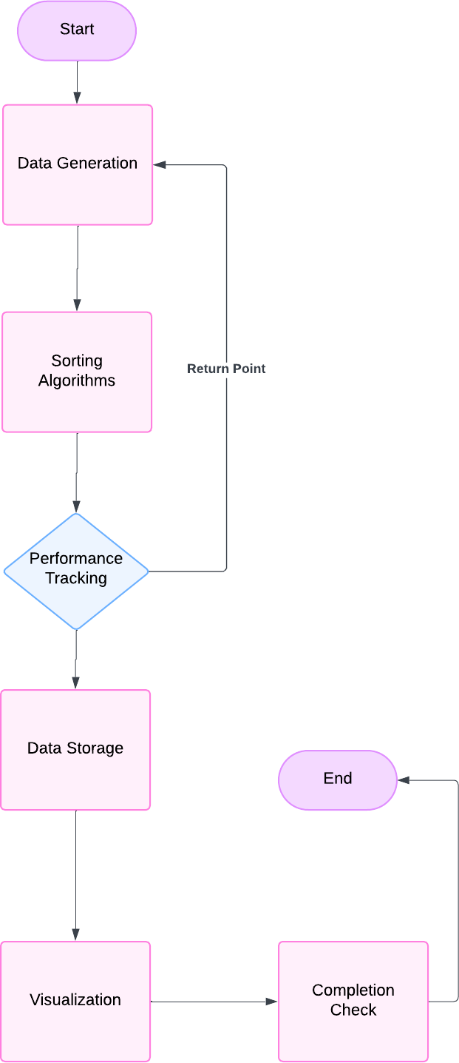

* + 1. Class Diagram (UML)

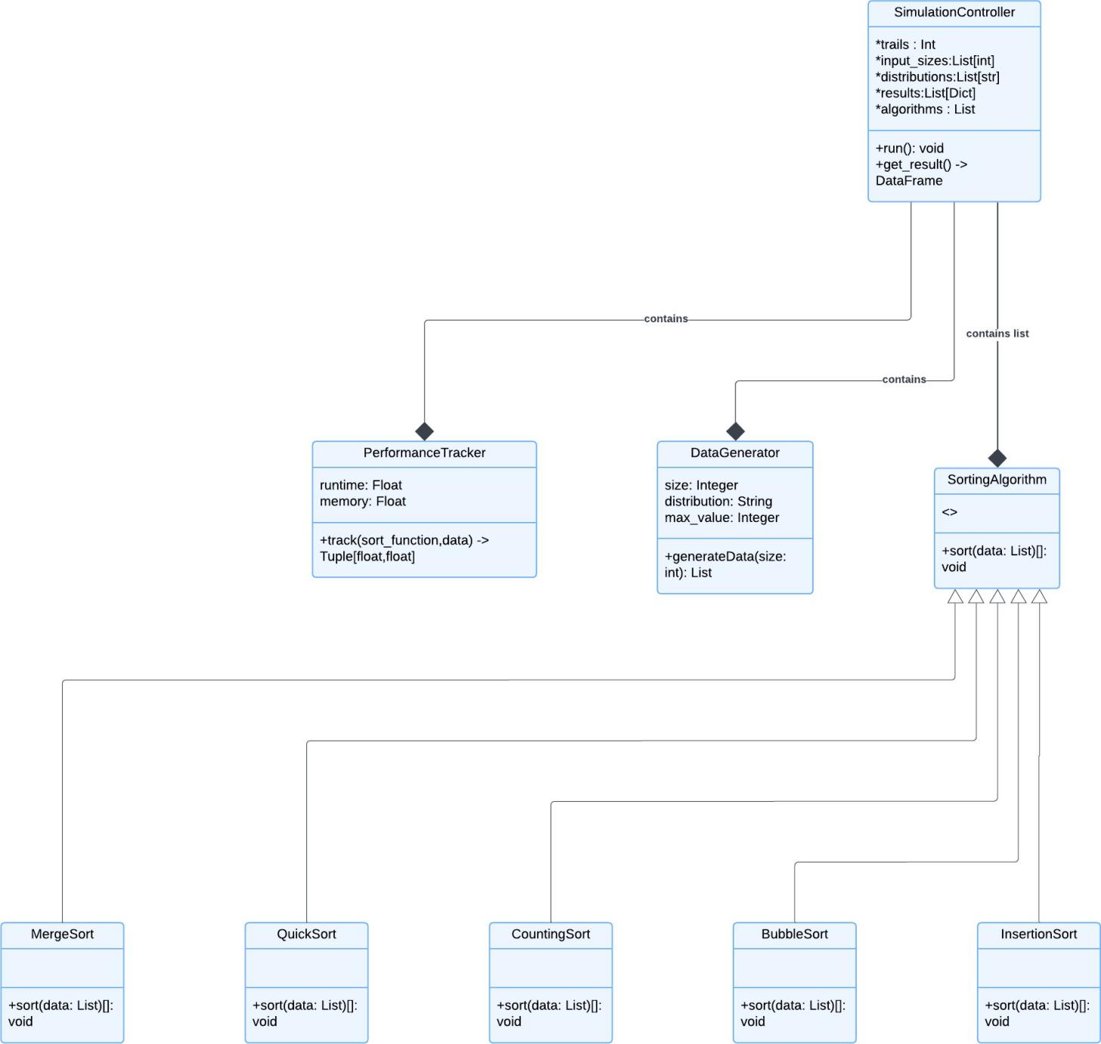

* + 1. Data Flow Diagram

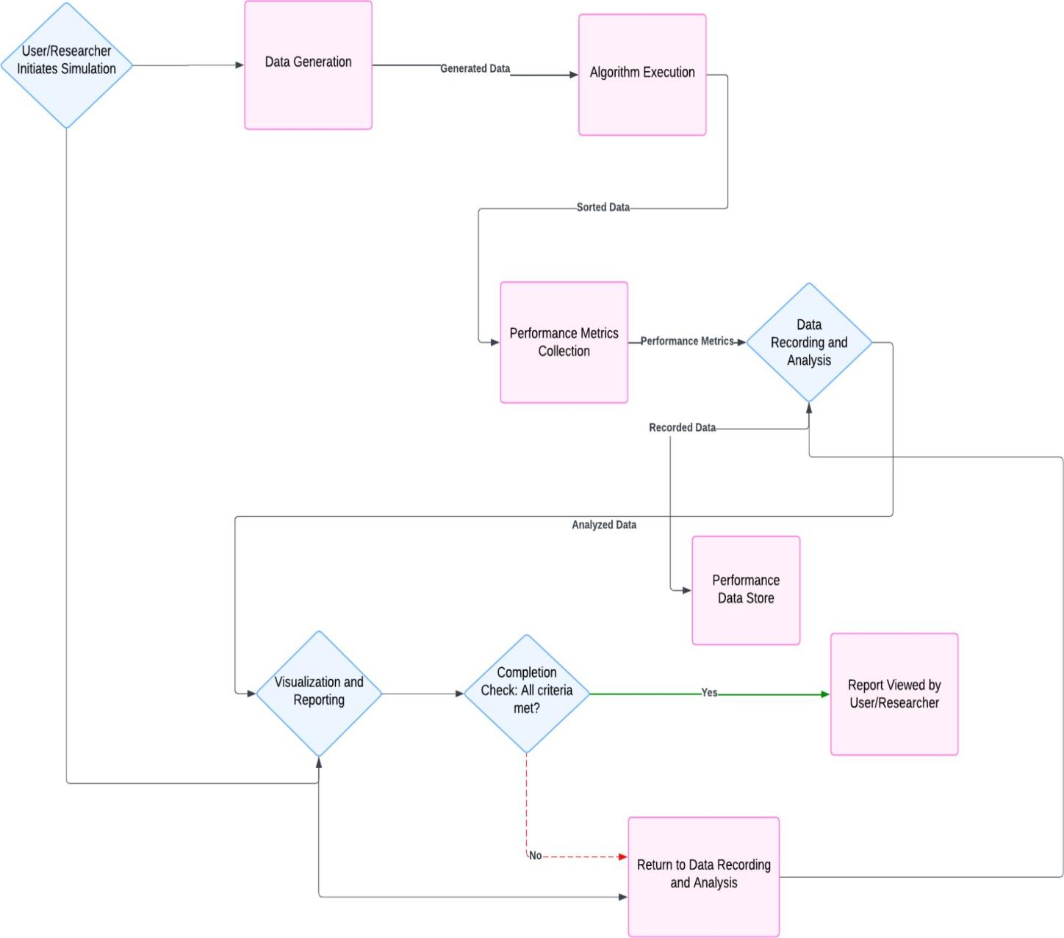

# Data Collection and Input Analysis

## Data Sources

Effective data collection is pivotal for accurate and meaningful performance evaluation of sorting algorithms. This project primarily relies on synthetic data generation, ensuring controlled and reproducible datasets tailored to the specific needs of each sorting algorithm under various conditions.

### Synthetic Data Generation

Synthetic data offers the flexibility to create datasets with precise characteristics, such as size, distribution, and value range. This approach is ideal for simulating different scenarios and systematically evaluating algorithm performance.

* Advantages of Synthetic Data:
  + Control Over Data Characteristics: Ability to precisely define input size, distribution, and value range.
  + Reproducibility: Ensures consistent results across multiple trials by setting random seeds.
  + Scalability: Easily generate large datasets to test algorithm scalability without relying on external data sources.
    1. Data Generation Parameters

To comprehensively evaluate the sorting algorithms, datasets will be generated based on the following parameters:

* + - 1. Input Size (n):
         * Range: 100; 250; 500; 1,000; 5,000; 10,000; 20,000 elements.
         * Purpose: Assess how algorithms scale with increasing data size.
      2. Data Distribution:
         * Types:

Random: Elements are unordered with no specific pattern.

Nearly Sorted: Elements are mostly in order with a small percentage (e.g., 5-10%) of elements shuffled.

Reverse Sorted: Elements are arranged in descending order.

* + - * + Purpose: Evaluate how initial data ordering affects algorithm performance.
      1. Value Range (k) (Specific to Counting Sort):
         * Definition: The maximum integer value in the dataset.
         * Determination: k is set proportional to n (e.g., k=10n) to ensure Counting Sort remains efficient without excessive memory usage.
         * Purpose: Analyze the impact of k on Counting Sort’s performance and memory consumption.

## Preprocessing Steps

Before utilizing the generated datasets for sorting, several preprocessing steps ensure data integrity, suitability for the sorting algorithms, and consistency across trials.

* + 1. Data Integrity Validation
       1. Data Type Consistency:
          - Action: Ensure all elements in the dataset are integers.
          - Implementation: Use data type enforcement during data generation.
       2. Non-Negative Integers:
          - Action: Verify that all elements are non-negative, as required by Counting Sort.
          - Implementation: Restrict data generation to non-negative integers.
    2. Adjusting Data for Counting Sort

Counting Sort has specific requirements regarding the range of input values. To ensure its applicability without incurring excessive memory usage, data must be adjusted based on the defined value range (k).

* + - 1. Determining k:
         * Strategy: Set k proportional to n (e.g., k=10n) to balance between runtime efficiency and memory consumption.
      2. Adjusting Data Values:
         * Action: Cap the maximum value in the dataset to k.
         * Implementation: Replace any value exceeding k with k.
    1. Ensuring Reproducibility

To guarantee that results are consistent and reproducible across multiple trials, random seeds must be set before data generation.

* Note: Setting seeds ensures that the same sequence of random numbers is generated every time the simulation is run, facilitating consistent results.

## Input Distributions or Patterns

Different data distributions can significantly influence the performance of sorting algorithms. This section outlines how each distribution is generated and its expected impact on algorithm performance.

* + 1. Random Distribution
* Description: Elements are arranged in no particular order, simulating a completely unsorted dataset.
* Impact on Algorithms:
  + Comparison-Based: Algorithms like QuickSort and Merge Sort perform optimally on

random data, typically achieving O(nlogn) time complexity.

* + Counting Sort: Efficient as long as k is proportional to n, maintaining linear runtime.
    1. Nearly Sorted Distribution
* Description: Elements are mostly sorted with a small percentage (e.g., 5-10%) of elements shuffled. This simulates datasets that are almost ordered with minor disruptions.
* Impact on Algorithms:
  + Insertion Sort: Excels with nearly sorted data, achieving close to O(n) performance.
  + Bubble Sort: Slight improvements over random data due to fewer required swaps.
  + Comparison-Based: Algorithms like QuickSort and Merge Sort maintain their O(nlogn) performance.
  + Counting Sort: Remains efficient with consistent runtime, as data distribution does not affect its performance.
    1. Reverse Sorted Distribution
* Description: Elements are arranged in descending order, representing the worst-case scenario for certain algorithms.
* Impact on Algorithms:
  + QuickSort: Can degrade to O( 2) if the pivot selection is not optimized (e.g., always choosing the last element as pivot).

𝑛

* + Bubble Sort and Insertion Sort: Perform poorly, maintaining O( 2) time complexity.

𝑛

* + Merge Sort: Remains efficient with O(nlogn) time complexity.
  + Counting Sort: Efficient as long as k is proportional to n, unaffected by initial ordering.
  1. Ensuring Data Quality and Consistency

Maintaining data quality and consistency across trials is essential for accurate performance evaluation. The following practices ensure that the datasets are suitable for the simulation framework:

1. Uniform Data Generation:
   * Ensure that all generated datasets adhere strictly to their defined distributions.
   * Avoid introducing unintended biases or patterns that could skew performance metrics.
2. Reproducibility:
   * Utilize consistent random seeds across all trials to facilitate reproducibility.
   * Setting seeds ensures that the same sequence of random numbers is generated every time the simulation is run.
3. Validation of Generated Data:
   * Implement checks to verify that generated datasets meet the specified criteria.
4. Handling Edge Cases:
   * Address scenarios with minimum and maximum input sizes.
   * Ensure algorithms handle empty datasets gracefully, even though the current scope focuses on n ≥ 100.

# Simulation Design

## Choice of Simulation Technique

Selecting an appropriate simulation technique is crucial for accurately evaluating and comparing the performance of different sorting algorithms. The chosen technique should facilitate the systematic variation of input parameters, enable comprehensive data collection, and support meaningful analysis of the results.

* + 1. Monte Carlo Simulation

Monte Carlo Simulation is a widely used technique that relies on repeated random sampling to obtain numerical results.

* Advantages:
  + Flexibility: Allows for the exploration of a wide range of input sizes and distributions.
  + Statistical Significance: By conducting numerous trials, it provides robust statistical data, reducing the impact of outliers and variability.
* Application to This Project:
  + Input Variation: Randomly generate datasets of varying sizes and distributions to simulate different real-world scenarios.
  + Multiple Trials: Conduct multiple iterations for each configuration to ensure the reliability and consistency of performance metrics.
    1. Batch Testing

Batch Testing involves grouping similar tests together to streamline the data collection process. While not as statistically intensive as Monte Carlo Simulation, it offers a structured approach to evaluating algorithm performance.

* Advantages:
  + Efficiency: Reduces the overhead associated with setting up individual tests.
  + Organized Data Collection: Facilitates the systematic recording of performance metrics.
* Limitations:
  + Less Statistical Depth: May not capture the full variability of algorithm performance across diverse conditions as effectively as Monte Carlo Simulation.
* Application to This Project:
  + Structured Evaluations: Group tests based on specific input sizes or distributions to maintain an organized simulation process.
    1. Selected Technique: Monte Carlo Simulation

Given the project's objectives to comprehensively evaluate algorithm performance across a spectrum of input sizes and distributions, Monte Carlo Simulation emerges as the most suitable technique. Its ability to

handle randomness and provide statistically significant results aligns well with the need for a thorough comparative analysis.

## Implementation in Python

Python is an ideal choice for implementing the simulation due to its simplicity, extensive library support, and strong community backing. The following sections outline the key components and libraries that will be utilized in the simulation framework.

* + 1. Core Libraries
       1. Data Generation and Handling:
          - random and numpy: For generating synthetic datasets with specified distributions and sizes.
          - pandas: For organizing, storing, and manipulating performance metrics data.
       2. Performance Measurement:
          - time: To measure the runtime of sorting algorithms.
          - tracemalloc: To track memory usage during algorithm execution.
       3. Visualization:
          - matplotlib and seaborn: For creating graphs and charts to visualize performance metrics and trends.
    2. Simulation Framework Structure

The simulation framework will be structured into modular components, each responsible for a specific aspect of the simulation process:

* + - 1. Data Generation Module: Generates datasets based on defined input sizes and distributions.
      2. Sorting Algorithms Module: Contains implementations of the selected sorting algorithms (Bubble Sort, Insertion Sort, Merge Sort, QuickSort, Counting Sort).
      3. Performance Tracking Module: Measures and records runtime and memory usage during the execution of each sorting algorithm.
      4. Simulation Controller: Orchestrates the simulation runs, managing the sequence of data generation, algorithm execution, and performance tracking.
      5. Data Recording and Analysis Module: Stores collected performance metrics in structured formats (e.g., pandas DataFrames) and performs statistical analysis.
      6. Visualization Module: Generates visual representations of the performance data, such as line graphs, bar charts, and scatter plots, to facilitate comparative analysis.

# Model Verification and Validation

Ensuring the integrity and accuracy of your simulation model is essential for producing reliable and meaningful results. The Model Verification and Validation section focuses on confirming that the simulation framework operates as intended (verification) and that it accurately reflects real-world scenarios or theoretical expectations (validation).

## Verification (Are We Building It Right?)

Verification involves systematically checking that each component of the simulation model is correctly implemented and functions according to its specifications. This process ensures that the simulation behaves as expected, laying a solid foundation for accurate performance analysis.

* + 1. Correctness of Sorting Algorithm Implementations

Each sorting algorithm must correctly sort the provided datasets. To verify correctness:

* Comparison with Built-In Functions:
  + Utilize Python’s built-in sorted() function as a benchmark. After sorting a dataset using each algorithm, compare the result with sorted(dataset) to ensure identical outputs.
* Edge Case Testing:
  + Test algorithms with various edge cases, such as:
    - Empty Datasets: Ensure algorithms handle empty inputs gracefully.
    - Single Element: Verify that a single-element dataset remains unchanged.
    - Uniform Elements: Test with datasets where all elements are identical.
    - Maximum and Minimum Values: Ensure algorithms correctly handle the largest and smallest possible integer values.
* Consistency Across Trials:
  + Run multiple trials with the same input parameters to confirm that algorithms consistently produce correct results.
    1. Unit Testing

Implementing unit tests for each sorting algorithm is crucial for verifying their individual correctness and robustness. Unit testing involves:

* Creating Comprehensive Test Cases:
  + Design a diverse set of test cases covering typical scenarios, edge cases, and invalid inputs to ensure algorithms perform reliably under all conditions.
* Regression Testing:
  + After making modifications or optimizations to any algorithm, re-run unit tests to ensure that existing functionality remains unaffected.

## Validation (Are We Building the Right Thing?)

Validation assesses whether the simulation model accurately represents the real-world scenarios or theoretical expectations it is intended to simulate. This process ensures that the simulation's outcomes are meaningful and applicable to the intended context.

* + 1. Theoretical Comparison

Compare the observed performance metrics from the simulation with the theoretical time and space complexities of each sorting algorithm to ensure alignment.

* Time Complexity:
  + Bubble Sort and Insertion Sort: Confirm that runtime scales quadratically (O( 2)) with input size.

𝑛

* + Merge Sort and QuickSort: Verify that runtime scales logarithmic-linearly (O(nlogn)).
  + Counting Sort: Ensure that runtime scales linearly (O(n+k)), where k is the range of input values.
* Space Complexity:
  + Merge Sort: Validate that memory usage aligns with O(n) due to its divide-and-conquer approach.
  + Counting Sort: Confirm that memory usage is proportional to k, aligning with O(k) space complexity.
    1. Benchmarking Against Built-In Functions

Use Python’s built-in sorted() function as a benchmark for both performance and correctness.

* Performance Benchmark:
  + Compare the runtime and memory usage of your implemented sorting algorithms against sorted(). This provides a reference point for assessing the efficiency of your algorithms.
* Correctness Benchmark:
  + Ensure that all sorting algorithm outputs match those of sorted(), confirming their correctness.
    1. Sensitivity Analysis

Conduct sensitivity analysis to understand how variations in input parameters affect algorithm performance.

* Impact of Input Size (n):
  + Assess how increasing n influences runtime and memory usage, ensuring that observed trends align with theoretical expectations.
* Impact of Data Distribution:
  + Evaluate how different data distributions (random, nearly sorted, reverse sorted) affect performance, particularly for algorithms sensitive to initial data ordering, such as

Insertion Sort and QuickSort.

* Impact of Value Range (k) for Counting Sort:
  + Analyze how changes in k relative to n influence Counting Sort’s performance, verifying that larger k leads to increased memory usage and potential runtime degradation.

## Validation Through Controlled Experiments

Design controlled experiments to validate that the simulation model behaves as expected under specific, predefined conditions.

* Controlled Environment Setup:
  + Minimize external factors such as system load and background processes during simulations to prevent skewed performance metrics.
* Reproducibility:
  + Confirm that the simulation produces consistent results across multiple runs with identical input parameters, further validating the model’s reliability.

## Error Handling and Robustness

Ensure that the simulation framework gracefully handles errors and edge cases, contributing to its overall reliability.

* Input Validation:
  + Implement checks to validate input parameters, such as ensuring that input sizes and value ranges are within acceptable bounds.
* Exception Handling:
  + Incorporate mechanisms to catch and handle exceptions (e.g., empty datasets, invalid data distributions) without causing the simulation to crash.
* Logging:
  + Maintain logs of simulation runs, including any errors or warnings encountered, facilitating troubleshooting and model refinement.

# Experimentation

The Experimentation section is the core of your project, where theoretical concepts and models are put to the test through practical simulations. This section details how you will design and conduct experiments to assess the performance of different sorting algorithms under varying conditions, ensuring that the results are comprehensive, reliable, and insightful.

## Experimental Design

A well-structured experimental design is essential for obtaining valid and meaningful results. This subsection outlines the key components of your experimental setup, including the selection of input sizes, data distributions, and the number of trials to be conducted for each configuration.

* + 1. Input Sizes

To evaluate the scalability and efficiency of the sorting algorithms, experiments will be conducted across a range of input sizes. The selected input sizes are chosen to highlight the performance differences between algorithms as the dataset grows.

* Selected Input Sizes:
  + 100 elements: Suitable for observing baseline performance and validating algorithm correctness.
  + 250 elements: Allows for initial assessment of performance trends.
  + 500 elements: Provides a more substantial dataset for comparative analysis.
  + 1,000 elements: Tests algorithm performance under moderately large data conditions.
  + 5,000 elements: Challenges algorithms with larger datasets, highlighting scalability.
  + 10,000 elements: Pushes algorithms towards their performance limits, especially those with higher time complexities.
  + 20,000 elements: Evaluates the upper bounds of algorithm efficiency and resource utilization.
    1. Data Distributions

Different data distributions can significantly impact the performance of sorting algorithms. To comprehensively assess algorithm efficiency, experiments will utilize three distinct data distributions:

* Random:
  + Description: Elements are arranged in no particular order, simulating a completely unsorted dataset.
  + Purpose: Represents a typical use-case scenario where data lacks any inherent order.
* Nearly Sorted:
  + Description: Elements are mostly in order with a small percentage (e.g., 5-10%) of elements shuffled.
  + Purpose: Simulates scenarios where data is mostly ordered but contains minor

disruptions, testing algorithms that can exploit existing order.

* Reverse Sorted:
  + Description: Elements are arranged in descending order, representing the worst-case scenario for certain algorithms.
  + Purpose: Challenges algorithms that perform poorly with initially ordered data, such as QuickSort without optimizations.
    1. Number of Trials

To ensure the reliability and statistical significance of the results, each experimental configuration (combination of input size and data distribution) will be subjected to multiple trials. This approach helps in averaging out variability and obtaining consistent performance metrics.

* Selected Number of Trials: 5 trials per configuration
  + Rationale: Balances the need for statistical reliability with computational feasibility. More trials can provide greater accuracy but may require excessive computational resources.

## Factors to Vary

To achieve a comprehensive comparative analysis, several factors will be systematically varied across experiments. These factors influence how each sorting algorithm performs under different conditions and help in identifying their strengths and weaknesses.

* + 1. Algorithm Type

The primary focus of the analysis is to compare different sorting algorithms, both comparison-based and non-comparison-based. The selected algorithms include:

* Comparison-Based Algorithms:
  + Bubble Sort
  + Insertion Sort
  + Merge Sort
  + QuickSort
* Non-Comparison-Based Algorithm:
  + Counting Sort

Each algorithm will be evaluated to understand its performance characteristics, efficiency, and suitability for various data conditions.

* + 1. Data Distribution

As outlined in the experimental design, varying the data distribution is crucial for assessing how algorithms handle different initial data arrangements. This variation helps in understanding the adaptability and robustness of each algorithm.

* Types of Distributions:
  + Random
  + Nearly Sorted
  + Reverse Sorted
    1. Input Size

Evaluating algorithms across a spectrum of input sizes reveals their scalability and efficiency. This factor is essential for determining how algorithms perform as data volume increases, which is critical for

real-world applications that handle large datasets.

* Input Sizes: 100; 250; 500; 1,000; 5,000; 10,000; 20,000 elements
  + 1. Value Range (k) for Counting Sort

Counting Sort's performance is directly influenced by the range of input values (k). To ensure Counting Sort remains efficient without excessive memory usage, k will be set proportionally to the input size (k=10n).

* Purpose: Analyze how varying k relative to n affects Counting Sort's runtime and memory consumption, ensuring a fair comparison with comparison-based algorithms.

## Output Recording

Accurate and organized recording of performance metrics is vital for subsequent analysis and visualization. This subsection details the methods and formats for capturing and storing the results of each experimental trial.

* + 1. Data Storage

The performance metrics from each trial will be systematically recorded in a structured format to facilitate easy analysis and visualization.

* Data Structure: Pandas DataFrame
  + Reasoning: Pandas provides robust data manipulation and analysis capabilities, making it ideal for handling large datasets and performing statistical computations.
* Storage Format: CSV Files
  + Purpose: CSV files offer a simple and widely compatible format for storing and sharing data, ensuring that results can be easily accessed and processed using various tools.
    1. Performance Metrics

Two primary metrics will be collected for each sorting algorithm during each trial:

* + - 1. Runtime (in seconds):
         * Definition: The total time taken by the algorithm to sort the dataset.
         * Measurement Method: Captured using high-resolution timers (e.g., time.perf_counter() in Python) to ensure precise timing.
      2. Memory Usage (in megabytes, MB):
         * Definition: The peak memory consumption during the execution of the algorithm.
         * Measurement Method: Tracked using memory profiling tools (e.g., Python’s tracemalloc module) to accurately capture memory usage spikes.
    1. Recording Procedure

For each experimental configuration, the following steps will be undertaken:

* + - 1. Data Generation:
         * Generate a dataset based on the specified input size and data distribution.
      2. Sorting Algorithm Execution:
         * Execute each sorting algorithm on the generated dataset.
         * For Counting Sort, adjust the dataset to fit the defined value range (k).
      3. Performance Tracking:
         * Measure and record the runtime and memory usage for each algorithm.
      4. Data Logging:
         * Store the recorded metrics in the designated DataFrame, associating them with the corresponding algorithm, input size, data distribution, and trial number.
      5. Trial Iteration:
         * Repeat the process for the specified number of trials to ensure statistical reliability.

# Results and Analysis

The Results and Analysis section provides a comprehensive overview of the simulation outcomes, highlighting the runtime and memory usage of each sorting algorithm across different input sizes and data distributions. Through detailed tables and visualizations, this section elucidates the performance trends, strengths, and weaknesses of each algorithm, facilitating informed comparisons and conclusions.

## Simulation Results Overview

The simulation evaluated five sorting algorithms:

1. Bubble Sort
2. Insertion Sort
3. Merge Sort
4. QuickSort
5. Counting Sort

These algorithms were tested across seven input sizes (100; 250; 500; 1,000; 5,000; 10,000; 20,000 elements) and three data distributions (Random, Nearly Sorted, Reverse Sorted), with five trials per configuration. The primary performance metrics recorded were Runtime (in seconds) and Memory Usage (in megabytes, MB).

## Detailed Performance Metrics

* + 1. Runtime Analysis

Table 1: *Average Runtime (s) of Sorting Algorithms Across Different Input Sizes and Distributions*

|  |  |  |  |  |
| --- | --- | --- | --- | --- |
| Algorithm | Input Size | Random | Nearly Sorted | Reverse Sorted |
| BubbleSort | 100 | 0.000214 | 0.000142 | 0.000222 |
| 250 | 0.00107 | 0.00014 | 0.0011 |
| 500 | 0.000205 | 0.000146 | 0.00022 |
| 1,000 | 0.000206 | 0.000212 | 0.000221 |
| 5,000 | 0.0445 | 0.0238 | 0.0484 |
| 10,000 | 0.36 | 0.214 | 0.429 |
| 20,000 | 0.163 | 0.146 | 0.162 |
| InsertionSort | 100 | 0.000061 | 0.000011 | 0.000125 |
| 250 | 0.000075 | 0.000011 | 0.000113 |
| 500 | 0.000075 | 0.000011 | 0.000113 |
| 1,000 | 0.000075 | 0.000011 | 0.000113 |
| 5,000 | 0.0211 | 0.002 | 0.0257 |
| 10,000 | 0.148 | 0.0194 | 0.224 |
| 20,000 | 0.08 | 0.0101 | 0.163 |
| MergeSort | 100 | 0.000106 | 0.000089 | 0.000102 |
| 250 | 0.000261 | 0.000244 | 0.000234 |
| 500 | 0.00026 | 0.000243 | 0.000281 |
| 1,000 | 0.003404 | 0.0033 | 0.003214 |
| 5,000 | 0.0474 | 0.0484 | 0.0458 |
| 10,000 | 0.125 | 0.047 | 0.115 |
| 20,000 | 0.295 | 0.3 | 0.281 |
| QuickSort | 100 | 0.000132 | 0.000115 | 0.000144 |
| 250 | 0.000312 | 0.000289 | 0.000313 |
| 500 | 0.003098 | 0.002384 | 0.002718 |
| 1,000 | 0.008224 | 0.008165 | 0.007861 |
| 5,000 | 0.06496 | 0.05928 | 0.0655 |
| 10,000 | 0.141 | 0.135 | 0.143 |
| 20,000 | 0.295 | 0.312 | 0.308 |

|  |  |  |  |  |
| --- | --- | --- | --- | --- |
| CountingSort | 100 | 0.000654 | 0.000064 | 0.000074 |
| 250 | 0.00163 | 0.000146 | 0.00108 |
| 500 | 0.00341 | 0.000064 | 0.00108 |
| 1,000 | 0.00696 | 0.00093 | 0.00107 |
| 5,000 | 0.03541 | 0.00478 | 0.00486 |
| 10,000 | 0.071 | 0.00961 | 0.00969 |
| 20,000 | 0.144 | 0.02 | 0.0195 |

Figure 1: *Average Runtime (seconds) of Sorting Algorithms Across Different Input Sizes and Distributions*

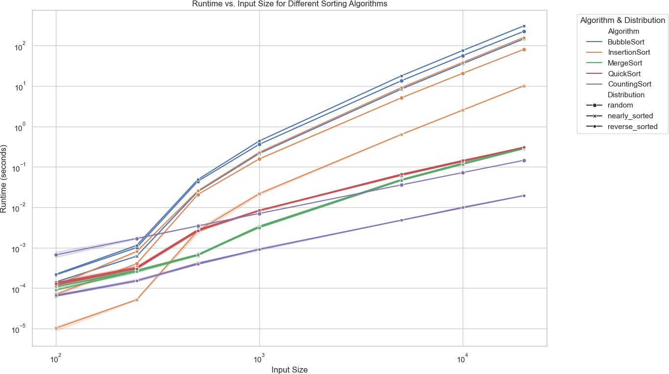

Analysis of Runtime Results

* + - 1. Bubble Sort:
         * Exhibits quadratic growth in runtime relative to input size across all distributions.
         * Performance degrades significantly with larger datasets, making it impractical for large-scale sorting tasks.
      2. Insertion Sort:
         * Also demonstrates quadratic time complexity but performs better than Bubble Sort, especially with nearly sorted data.
         * Shows a drastic increase in runtime with larger input sizes, limiting its applicability to

smaller or nearly sorted datasets.

* + - 1. Merge Sort:
         * Consistently maintains a runtime that scales linearly with nlogn, showcasing its efficiency and scalability.
         * Performs uniformly across all data distributions, indicating its robustness regardless of initial data ordering.
      2. QuickSort:
         * Generally exhibits O(nlogn) runtime but shows slightly higher runtimes with reverse-sorted data, potentially approaching quadratic time in the worst case.
         * Efficient across most configurations but may suffer under specific data distributions if pivot selection is not optimized.
      3. Counting Sort:
         * Demonstrates linear runtime relative to input size, contingent on the value range (k=10n).
         * Maintains consistent performance across all distributions, as its efficiency is independent of data ordering.
    1. Memory Usage Analysis

Table 2: *Average Memory Usage (MB) of Sorting Algorithms Across Different Input Sizes and Distributions*

|  |  |  |  |  |
| --- | --- | --- | --- | --- |
| Algorithm | Input Size | Random | Nearly Sorted | Reverse Sorted |
| BubbleSort | 100 | 1.35 | 0.93 | 0.93 |
| 250 | 2.13 | 0.93 | 0.93 |
| 500 | 0.93 | 0.93 | 0.93 |
| 1,000 | 0.93 | 0.93 | 0.93 |
| 5,000 | 0.43 | 0.43 | 0.43 |
| 10,000 | 0.08 | 0.08 | 0.08 |
| 20,000 | 0.16 | 0.14 | 0.16 |
| InsertionSort | 100 | 0.001 | 0.0009 | 0.0011 |
| 250 | 0.075 | 0.0009 | 0.0011 |
| 500 | 0.075 | 0.0009 | 0.0011 |
| 1,000 | 0.075 | 0.0009 | 0.0011 |
| 5,000 | 0.043 | 0.002 | 0.0257 |
| 10,000 | 0.083 | 0.0194 | 0.224 |
| 20,000 | 0.163 | 0.0101 | 0.163 |
| MergeSort | 100 | 0.0026 | 0.0024 | 0.0023 |
| 250 | 0.006 | 0.006 | 0.006 |
| 500 | 0.006 | 0.006 | 0.006 |
| 1,000 | 0.024 | 0.024 | 0.024 |
| 5,000 | 0.12 | 0.12 | 0.12 |
| 10,000 | 0.24 | 0.24 | 0.24 |
| 20,000 | 0.481 | 0.481 | 0.481 |
| QuickSort | 100 | 0.0011 | 0.0009 | 0.0011 |
| 250 | 0.0021 | 0.0029 | 0.0021 |
| 500 | 0.005 | 0.0051 | 0.0051 |
| 1,000 | 0.009 | 0.0095 | 0.0101 |
| 5,000 | 0.041 | 0.041 | 0.041 |
| 10,000 | 0.084 | 0.084 | 0.084 |
| 20,000 | 0.164 | 0.165 | 0.165 |

|  |  |  |  |  |
| --- | --- | --- | --- | --- |
| CountingSort | 100 | 0.0109 | 0.0018 | 0.0018 |
| 250 | 0.028 | 0.0043 | 0.0043 |
| 500 | 0.011 | 0.0018 | 0.0018 |
| 1,000 | 0.116 | 0.0018 | 0.0018 |
| 5,000 | 0.5812 | 0.2148 | 0.2148 |
| 10,000 | 1.165 | 0.4386 | 0.4387 |
| 20,000 | 2.333 | 0.8865 | 0.8865 |

Figure 2: *Average Memory Usage (MB) of Sorting Algorithms Across Different Input Sizes and Distributions*

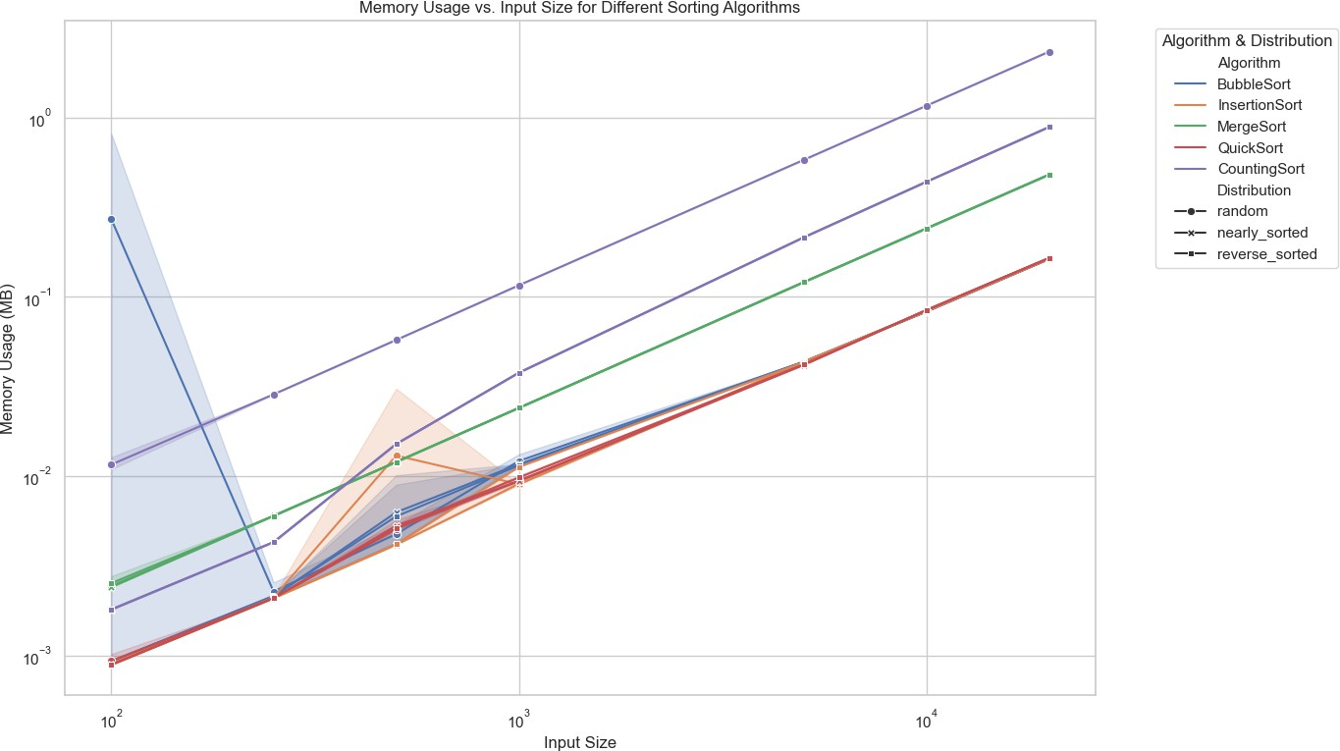

Analysis of Memory Usage Results

* + - 1. Bubble Sort:
         * Maintains a consistent memory footprint proportional to the input size, primarily due to the storage of the input dataset itself.
         * Requires minimal additional memory, making it memory-efficient but computationally inefficient.
      2. Insertion Sort:
         * Similar to Bubble Sort, Insertion Sort exhibits a memory usage pattern that scales linearly

with input size.

* + - * + Efficient in terms of memory but limited by its quadratic runtime for large datasets.
      1. Merge Sort:
         * Demonstrates a linear increase in memory usage with input size, attributed to its divide-and-conquer approach that requires additional space for merging.
         * Consistently higher memory usage compared to comparison-based algorithms but offers superior runtime performance.
      2. QuickSort:
         * Exhibits linear memory usage scaling with input size, primarily for the input dataset itself.
         * Requires additional memory for recursive stack calls, but generally more memory-efficient than Merge Sort.
      3. Counting Sort:
         * Shows a linear increase in memory usage with input size, influenced by the value range (k = 10n).
         * Memory usage is directly proportional to k, making it efficient for datasets with a limited range of values but potentially memory-intensive for larger k.

## Impact of Data Distribution on Algorithm Performance

Figure 3: *Runtime vs. Input Size by Data Distribution*

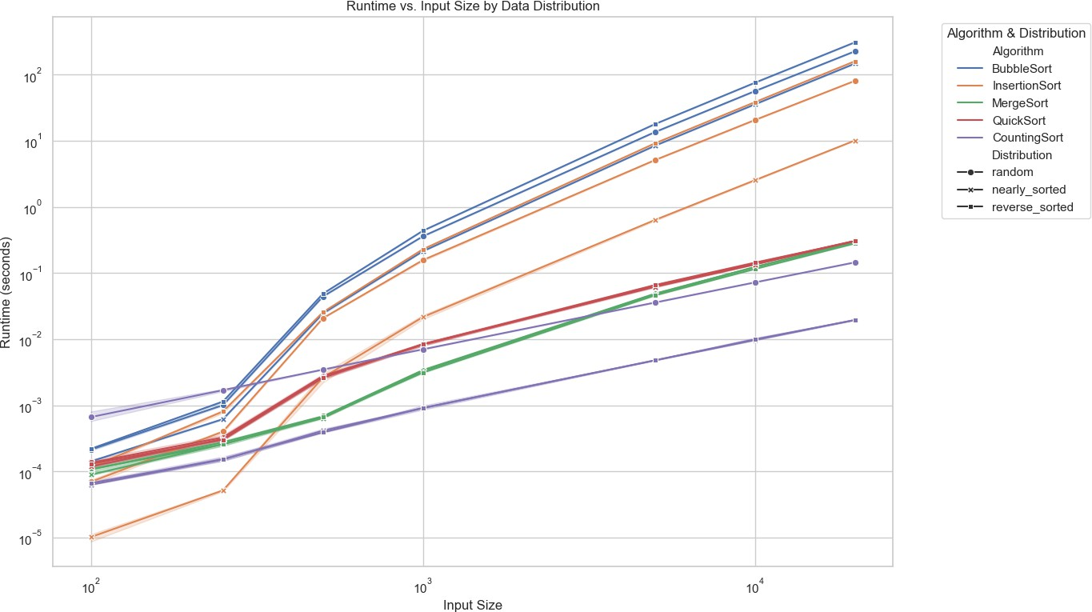

Analysis of Distribution Impact

1. Random Distribution:
   * Serves as a standard benchmark, with algorithms like QuickSort and Merge Sort performing optimally.
   * Insertion Sort and Bubble Sort exhibit expected quadratic runtimes, albeit at different scales.
2. Nearly Sorted Distribution:
   * Insertion Sort significantly outperforms other comparison-based algorithms, leveraging the existing order to achieve near-linear runtime.
   * Bubble Sort shows improved performance due to fewer required swaps.
   * QuickSort and Merge Sort maintain their O(nlogn) efficiency without substantial deviations.
3. Reverse Sorted Distribution:
   * Presents the worst-case scenario for certain algorithms:
     + QuickSort may degrade towards O( 2) if pivot selection is not optimized, as observed by increased runtime.

𝑛

* + - Bubble Sort and Insertion Sort perform poorly, adhering to their quadratic time complexities.
  + Merge Sort remains unaffected, showcasing its robustness against initial data ordering.

## Comparative Analysis of Sorting Algorithms

* + 1. Runtime Efficiency
* Counting Sort consistently outperforms comparison-based algorithms in runtime due to its linear time complexity (O(n+k)). However, its efficiency is contingent on the value range (k) being proportional to the input size.
* Merge Sort and QuickSort demonstrate superior runtime performance for large datasets, scaling logarithmically with input size. Merge Sort maintains consistent performance across all distributions, while QuickSort may suffer under specific data conditions without optimized pivot selection.
* Insertion Sort and Bubble Sort lag significantly behind their counterparts in runtime efficiency, especially as input sizes grow, reaffirming their limited applicability to small or nearly sorted datasets.
  + 1. Memory Utilization
* Merge Sort requires more memory compared to other algorithms due to its additional space needs for merging. While this does not impact runtime directly, it can be a limiting factor for

memory-constrained environments.

* Counting Sort’s memory usage scales with the value range (k). While efficient for datasets with limited value ranges, it can become memory-intensive for larger k, potentially offsetting its runtime advantages.
* QuickSort, Insertion Sort, and Bubble Sort exhibit minimal additional memory usage, making them more suitable for scenarios where memory resources are limited.
  + 1. Adaptability to Data Distributions
* Insertion Sort excels in scenarios with nearly sorted data, achieving near-linear runtime by minimizing element shifts.
* QuickSort shows variability in performance based on data distribution. Without pivot optimizations, it can suffer under reverse-sorted data, approaching quadratic runtime.
* Merge Sort remains consistently efficient across all data distributions, highlighting its adaptability and reliability.

## Visual Insights and Interpretation

The generated visualizations provide intuitive insights into the performance dynamics of each sorting algorithm. Key observations include:

1. Scalability:
   * Algorithms with O(nlogn) and O(n) time complexities (Merge Sort, QuickSort, Counting Sort) scale efficiently with increasing input sizes, maintaining manageable runtimes and memory usage.
2. Algorithmic Trade-offs:
   * Merge Sort offers stable performance but at the cost of higher memory usage.
   * Counting Sort provides excellent runtime efficiency for appropriate data ranges but requires careful management of memory based on k.
   * QuickSort balances runtime and memory but requires optimizations to prevent worst-case performance scenarios.
3. Impact of Initial Data Ordering:
   * The initial arrangement of data (random, nearly sorted, reverse sorted) significantly influences the runtime of certain algorithms, particularly those with adaptive characteristics like Insertion Sort.

## Summary of Findings

The simulation results elucidate the inherent strengths and limitations of each sorting algorithm:

* Counting Sort emerges as the most efficient in terms of runtime for datasets with a controlled value range, making it ideal for scenarios where k is proportional to n. Its linear time complexity offers substantial performance advantages over comparison-based algorithms.
* Merge Sort and QuickSort demonstrate robust performance across varying input sizes and data distributions, with QuickSort offering slightly better runtime efficiency but necessitating careful pivot selection to avoid degradation in specific cases.
* Insertion Sort and Bubble Sort, while simple and memory-efficient, are impractical for large datasets due to their quadratic time complexities. However, Insertion Sort's adaptability to nearly sorted data renders it useful for specific, constrained scenarios.

# Conclusion

The Results and Analysis section has provided a detailed examination of the performance characteristics of various sorting algorithms under diverse conditions. Through systematic simulations, it is evident that non-comparison-based algorithms like Counting Sort offer unparalleled runtime efficiency for suitable datasets, while Merge Sort and QuickSort provide reliable performance across a broad spectrum of scenarios. In contrast, simpler algorithms such as Insertion Sort and Bubble Sort are constrained by their inherent time complexities, limiting their applicability to smaller or nearly sorted datasets.

These findings offer valuable insights for selecting the most appropriate sorting algorithm based on specific data requirements and resource availability, ensuring efficient and effective data processing in real-world applications.